1. Create project structure like this:

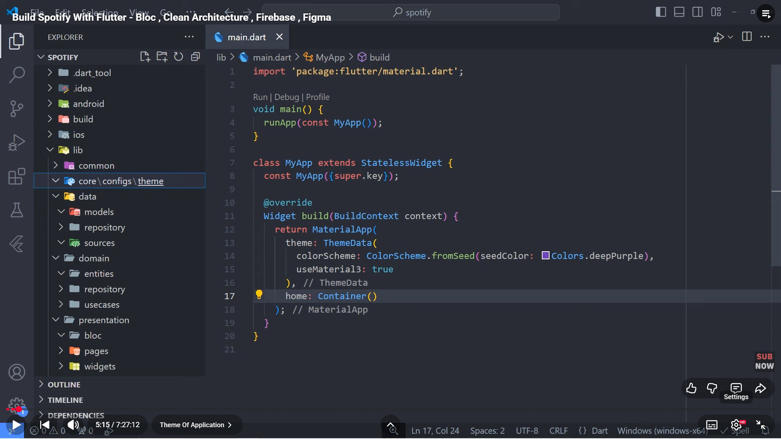

1. App_colors:

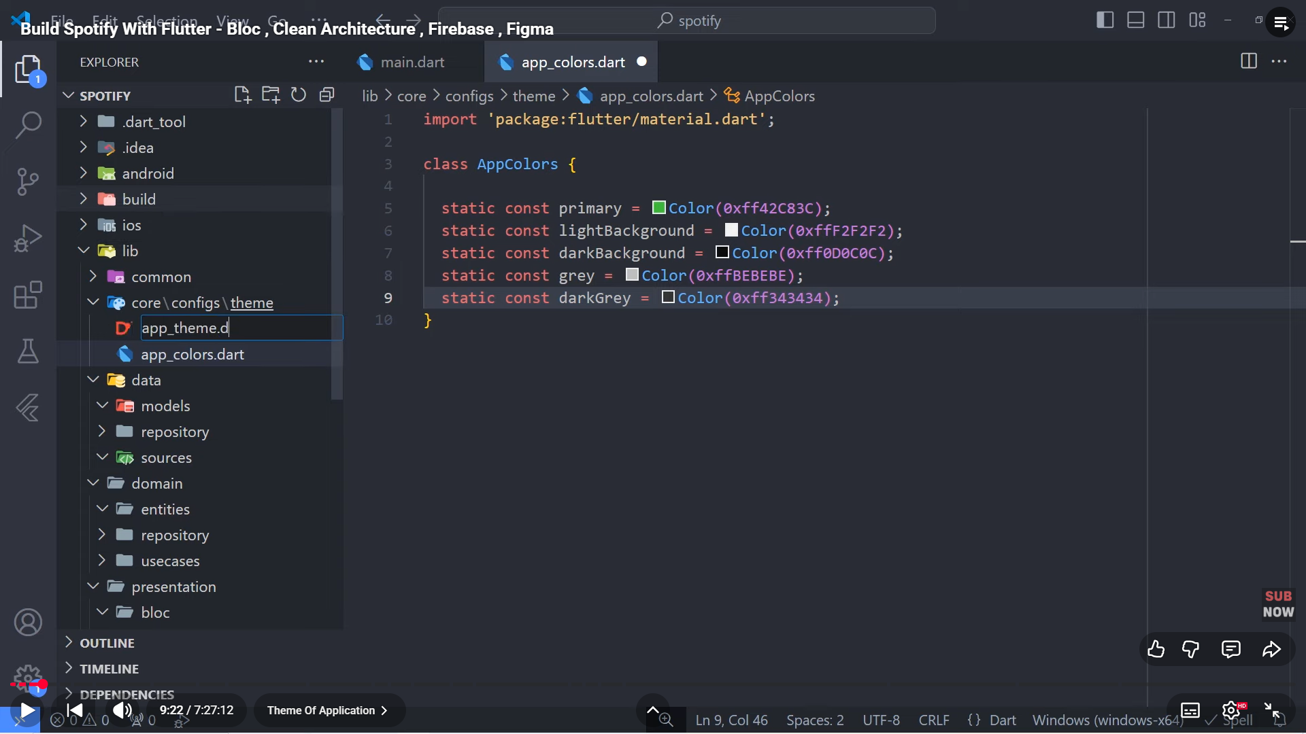

1. App_theme:

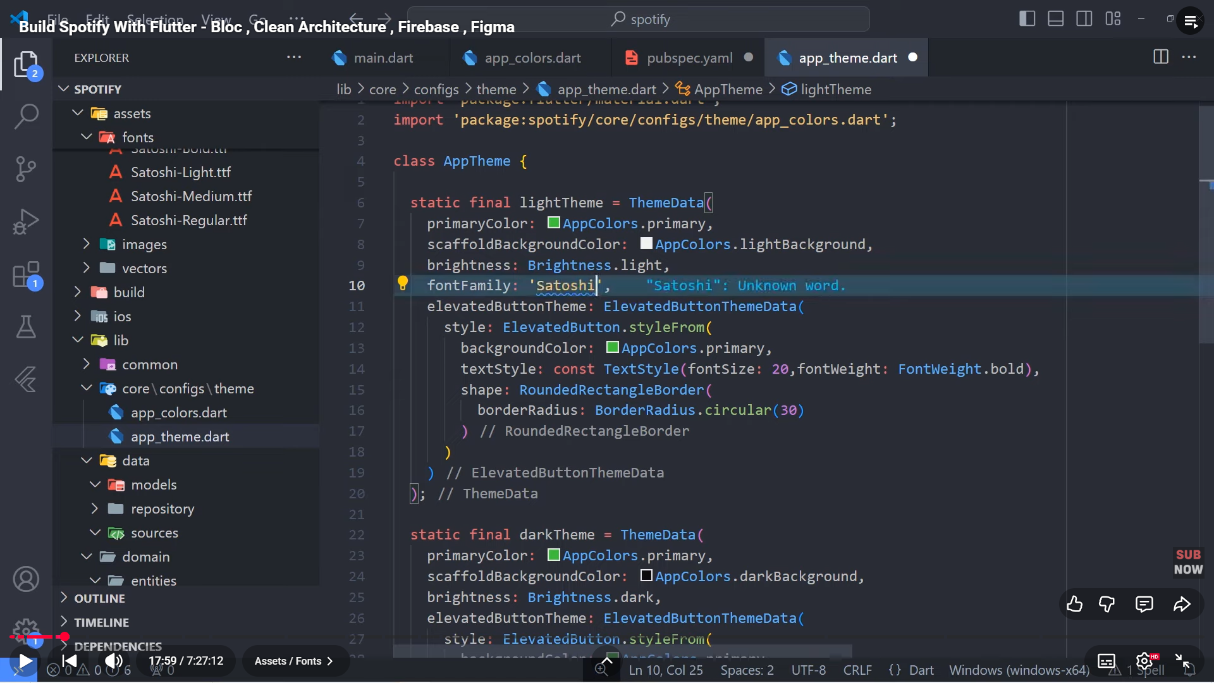

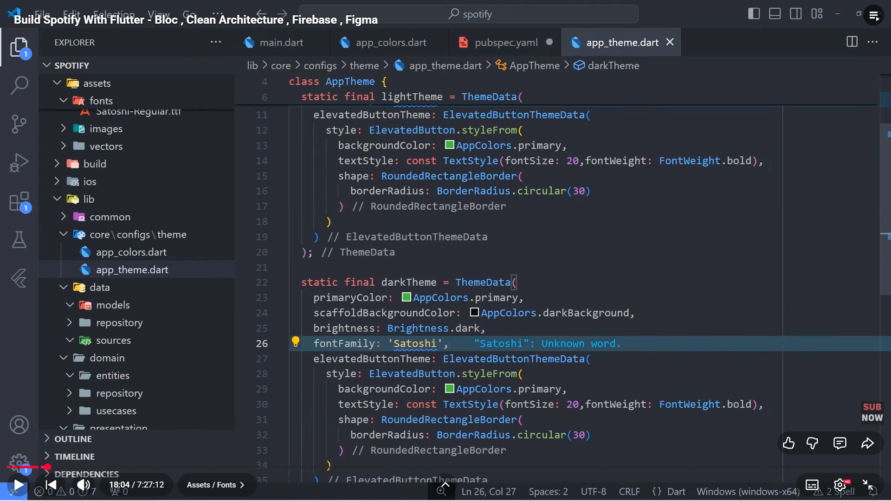

1. Configure:

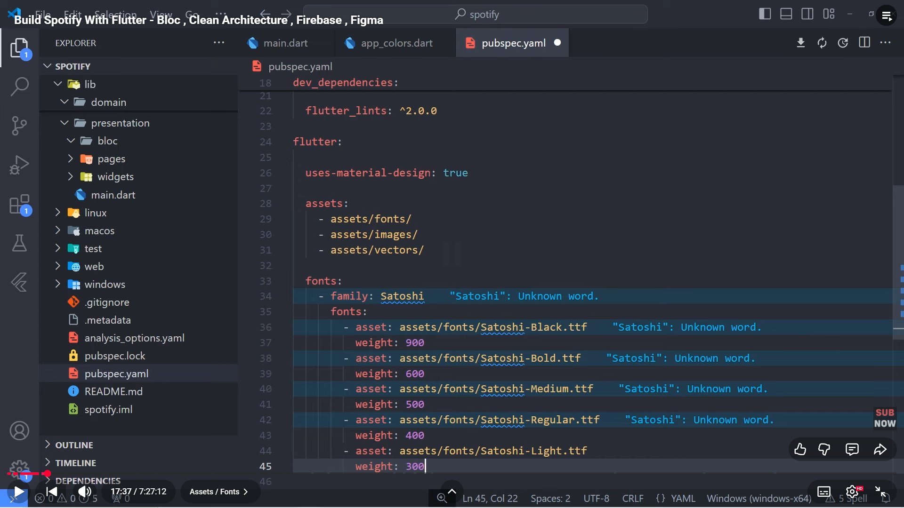

1. Create folder presentation/splash/bloc, pages/splash, widgets and assets inside core/configs

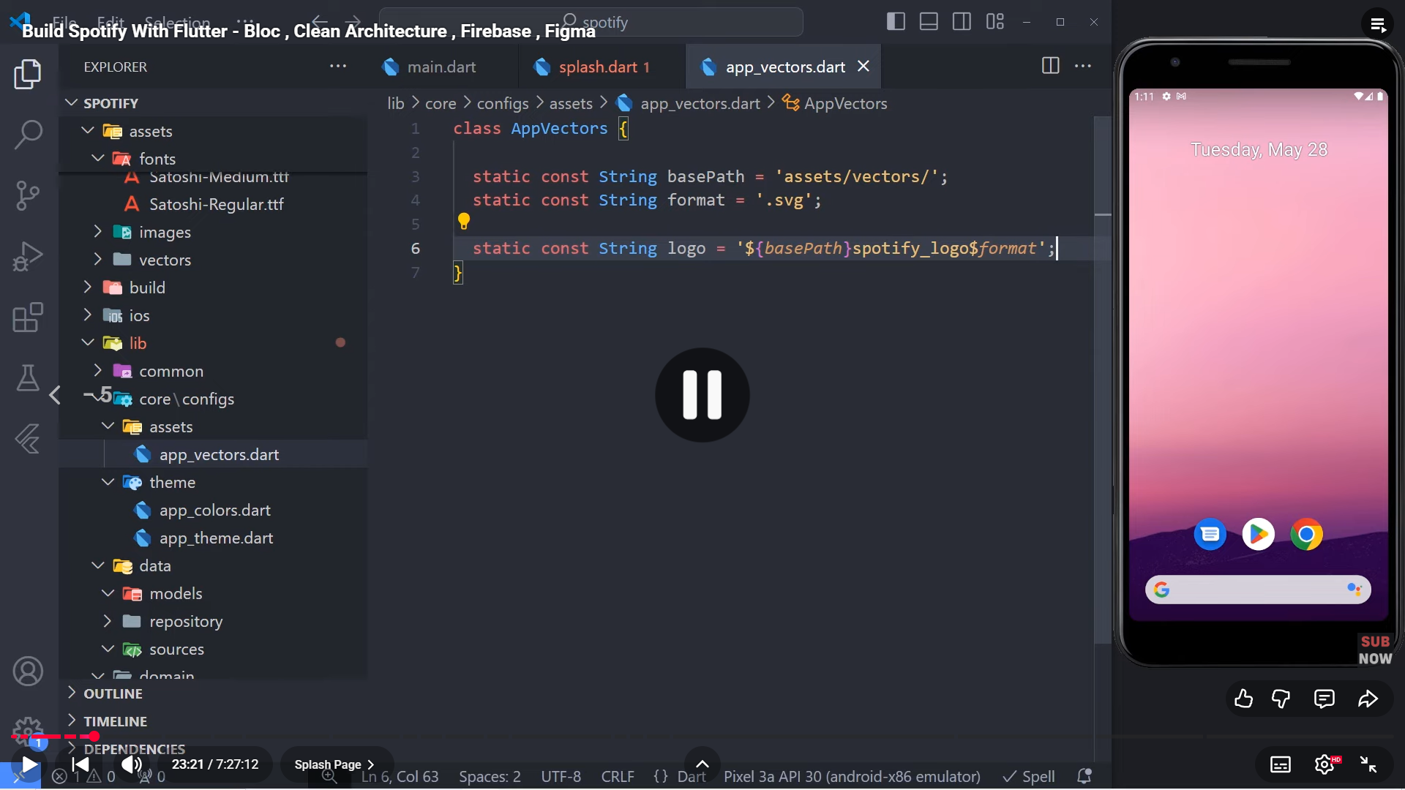

1. Add flutter_svg: in pubspec.yml after cupertino_icons: ^1.0.8
2. Create future function inside splash called redirect to startPage
3. Create file widgets/button/basic_app_button inside common

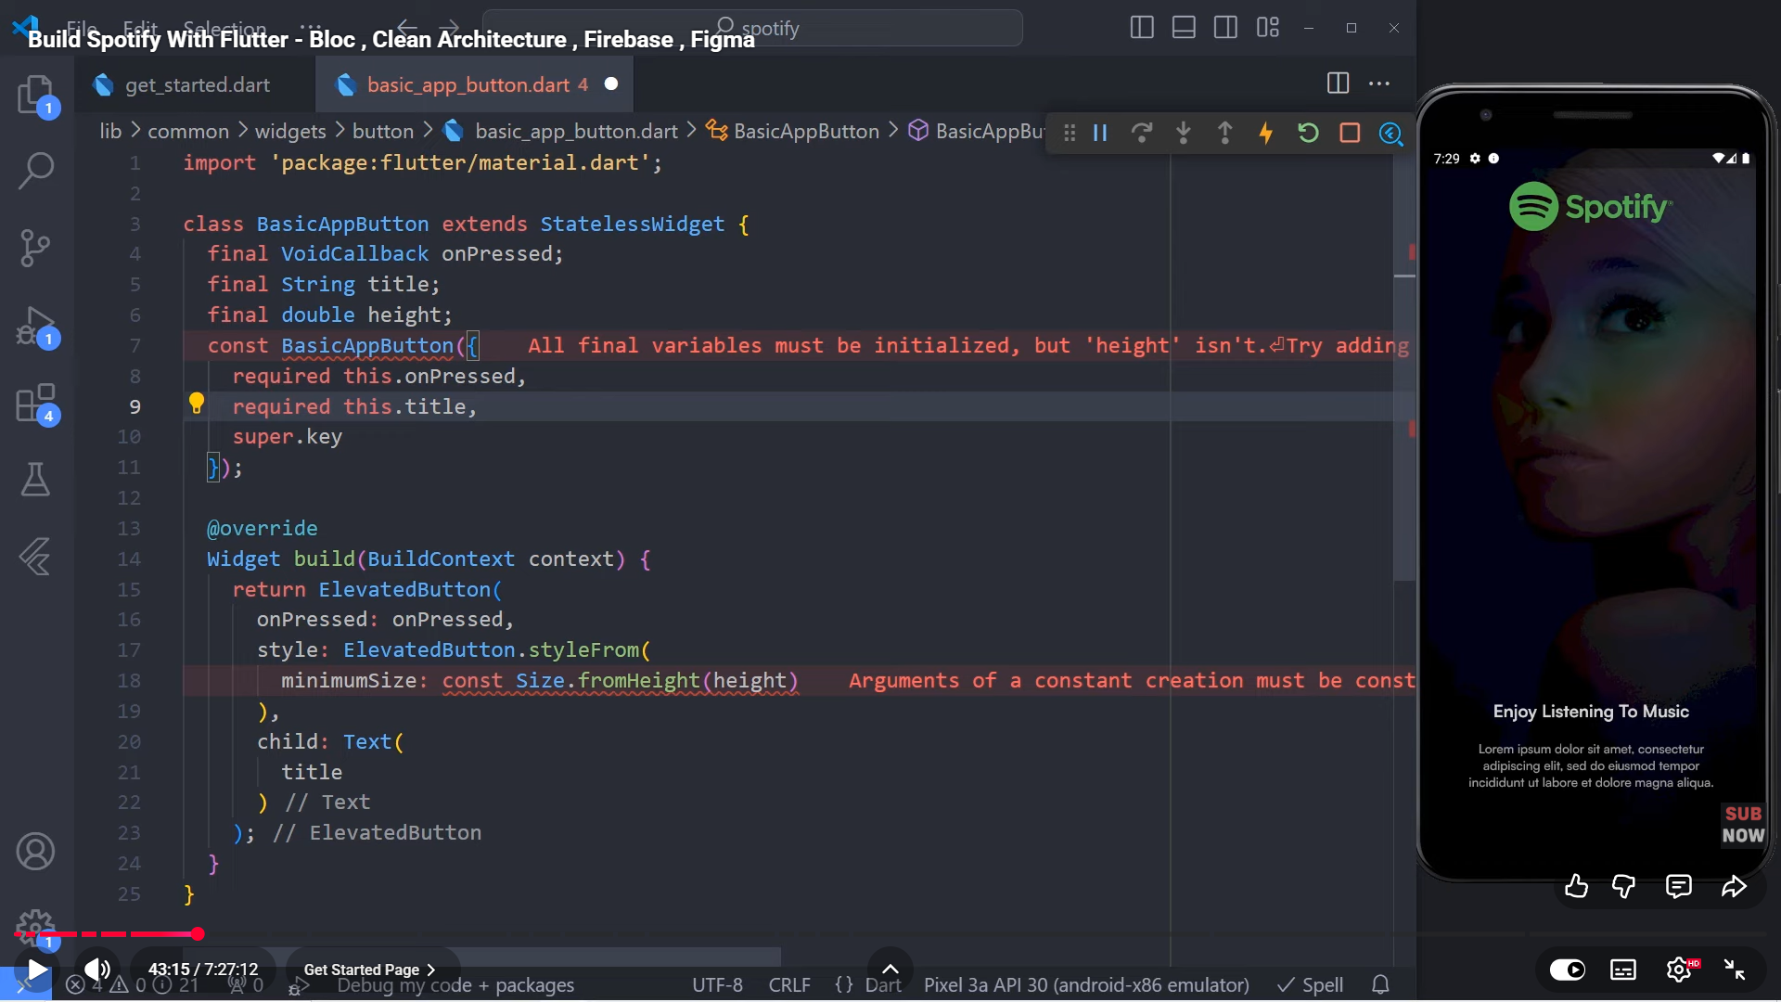

1. Get started will be like this:

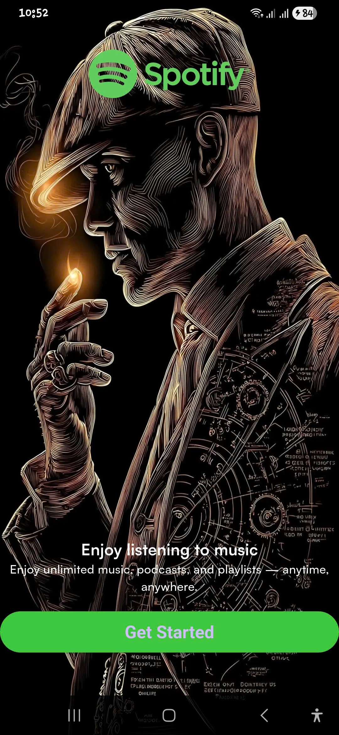

1. Create folder choose_mode in presentation
2. Choose_made will be like this:



1. Use bloc to manage state:

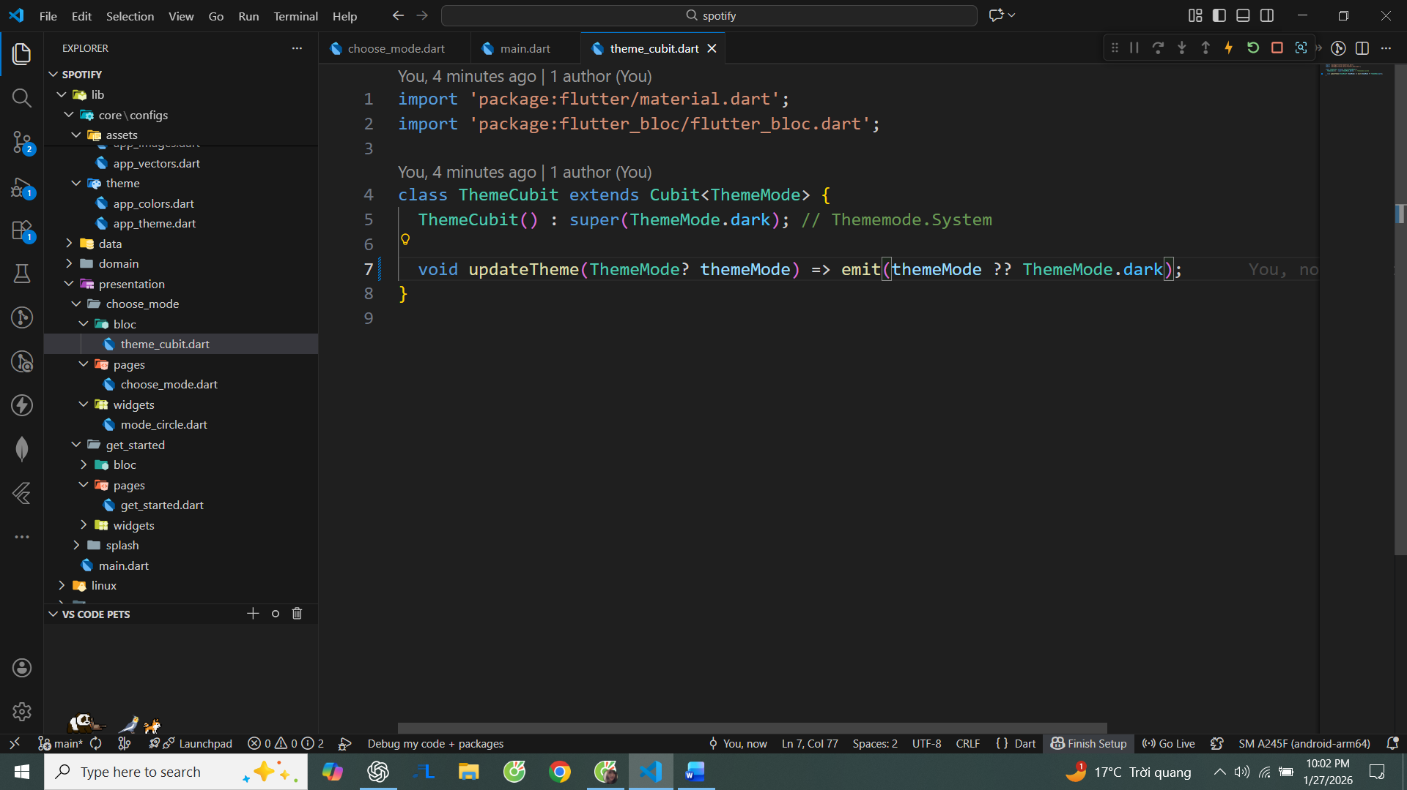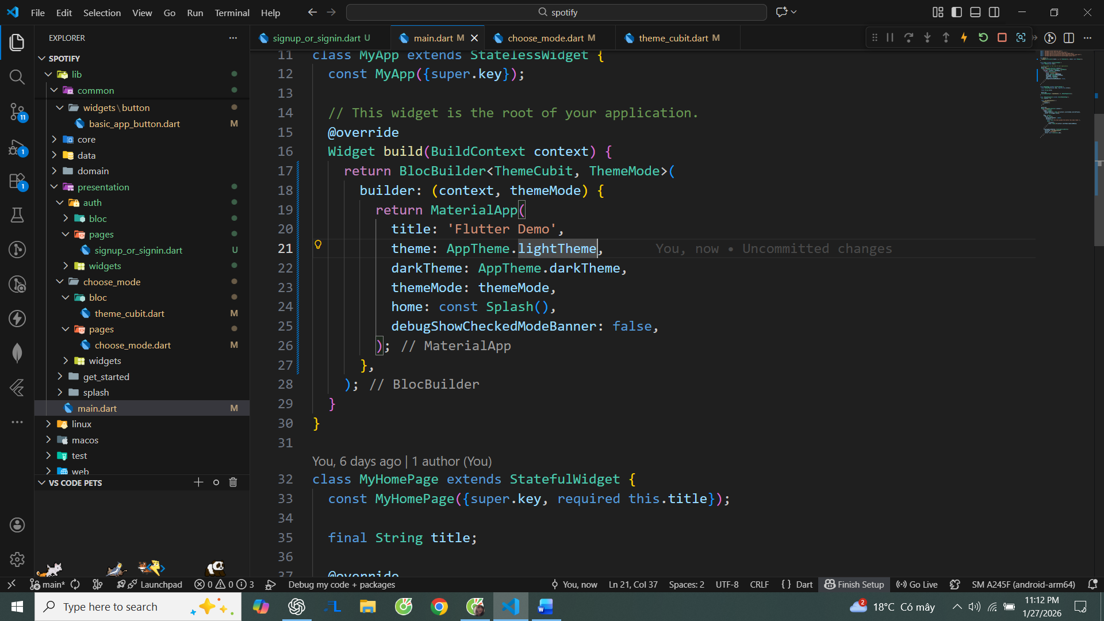

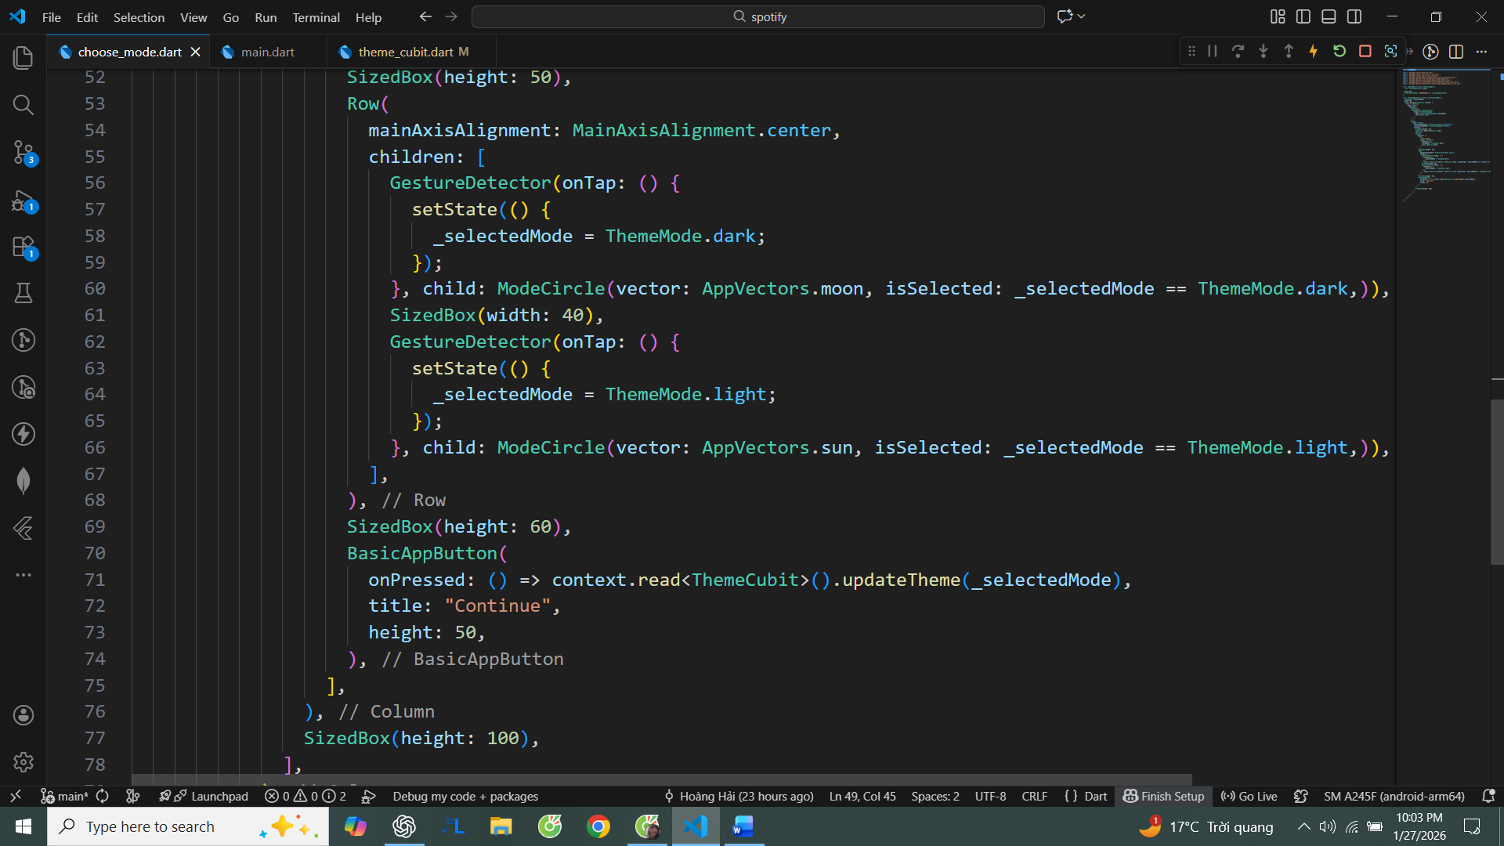

1. ModeCircle:

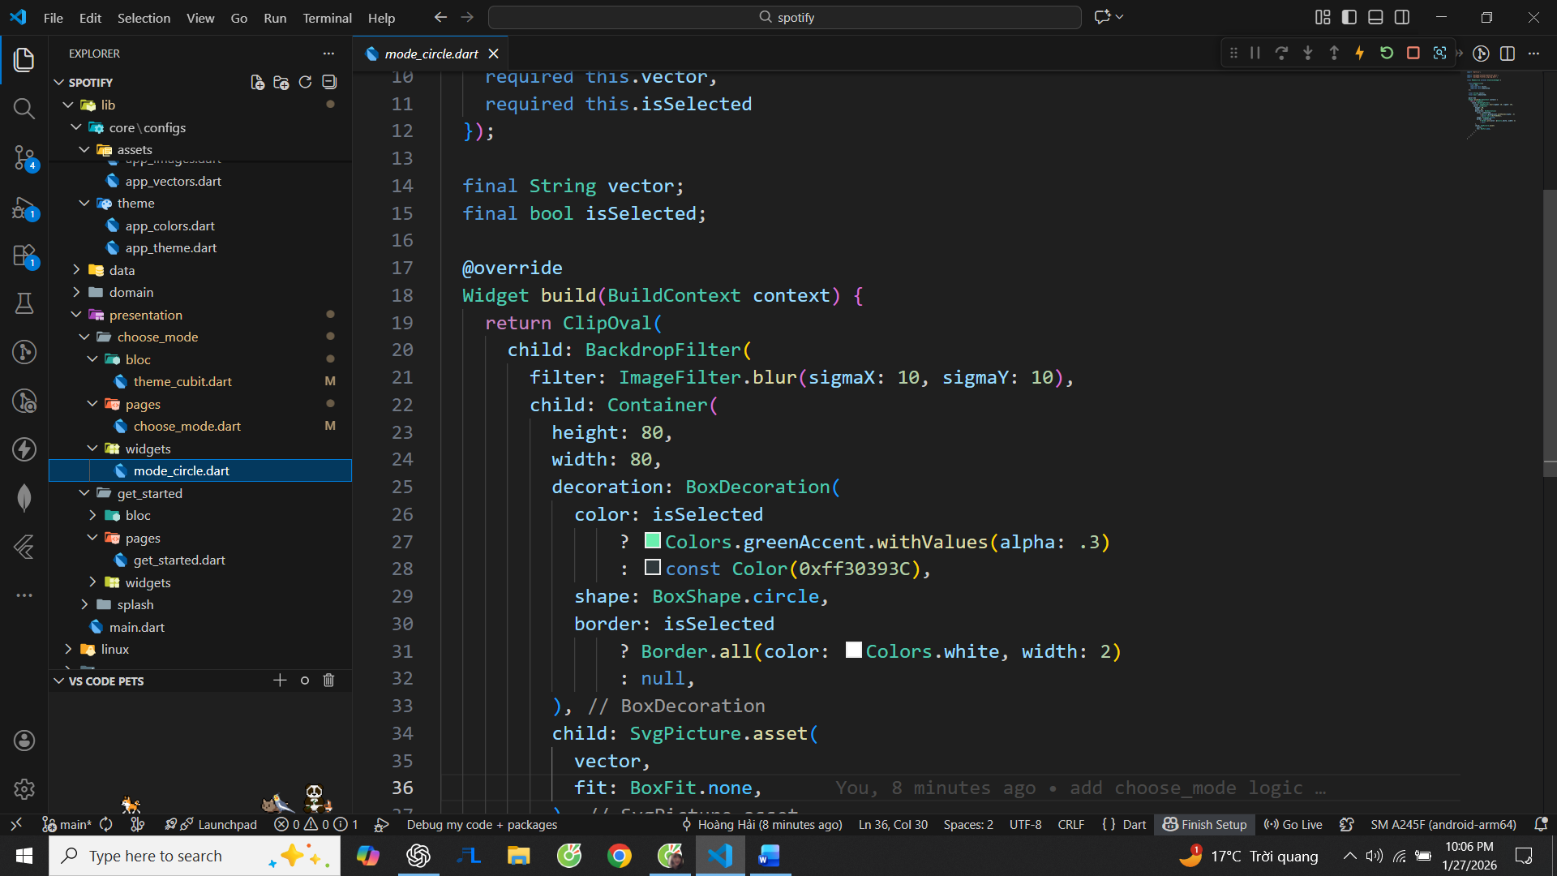

1. Create folder auth in presentation and create signup_or_signin.dart
2. Create folder helpers in common:

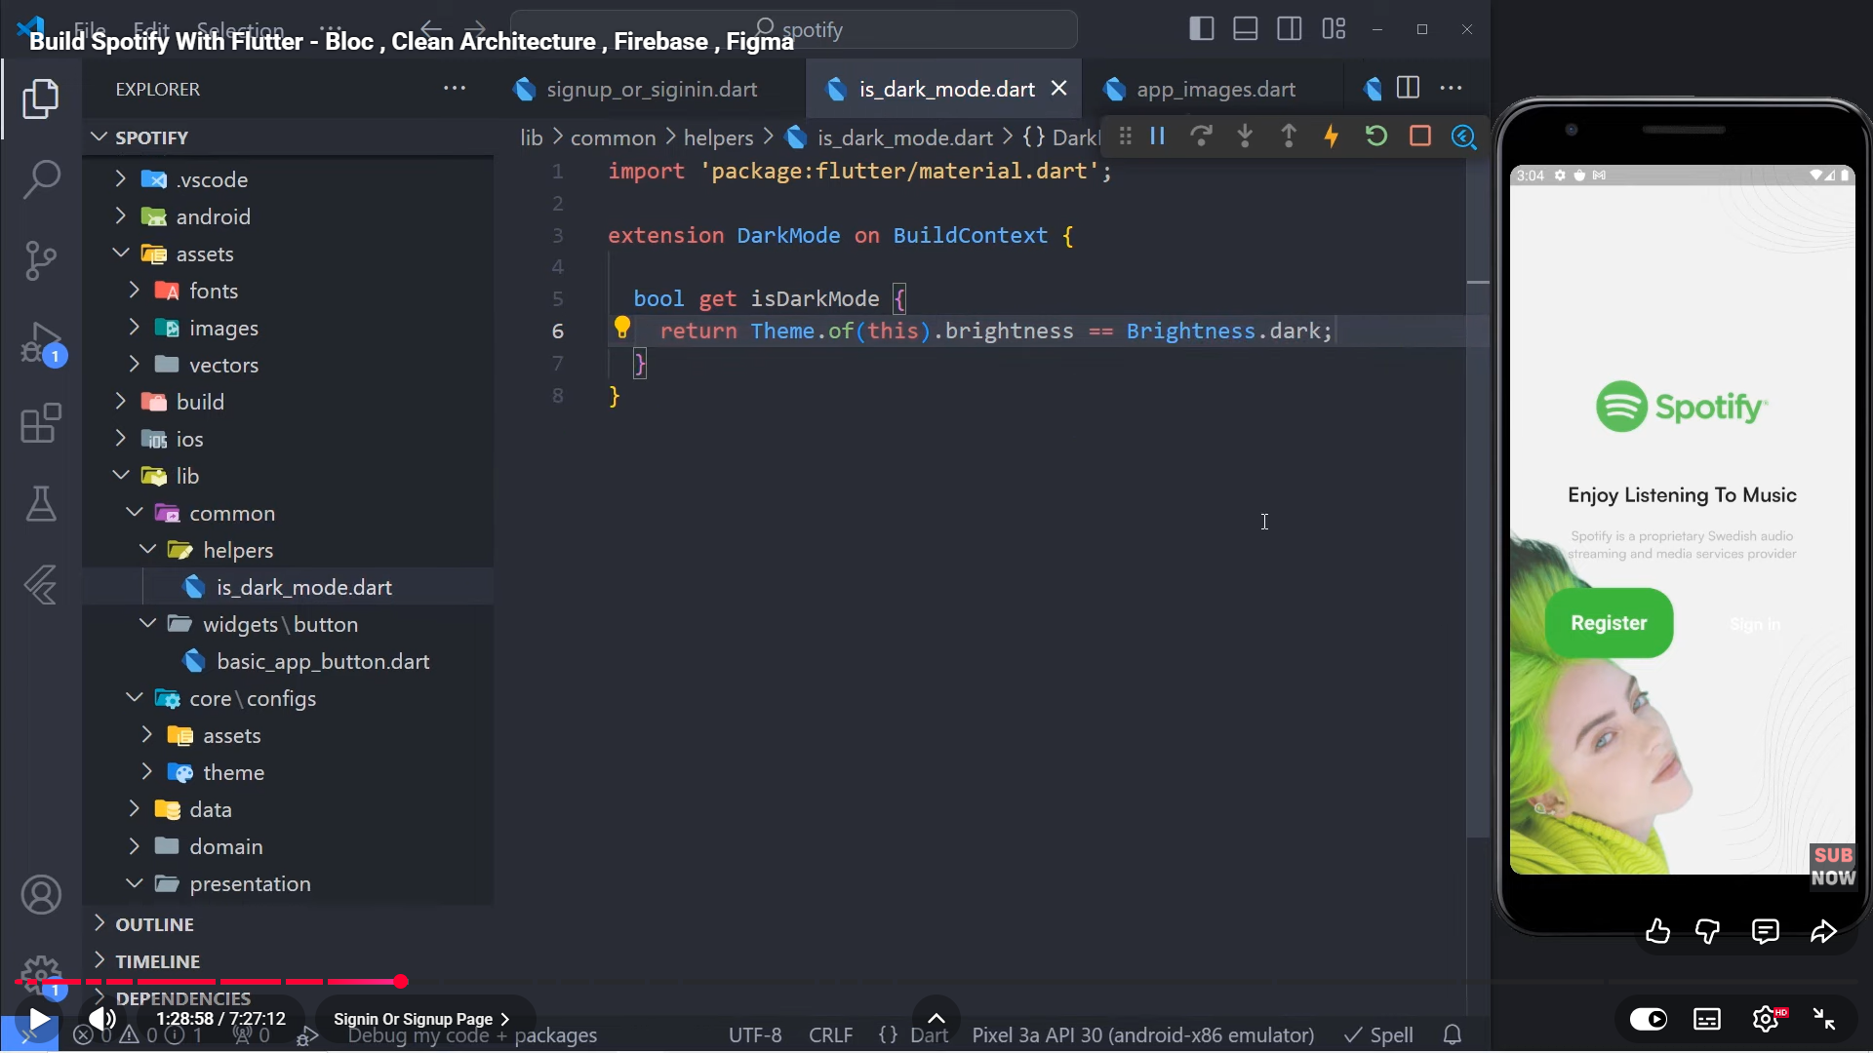

1. Sign up or sign in page will be like this:



1. Add additional information into app_theme:

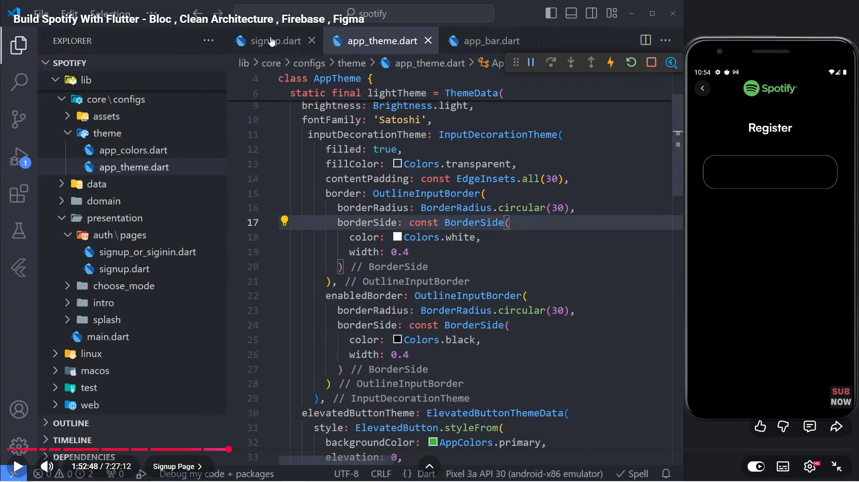

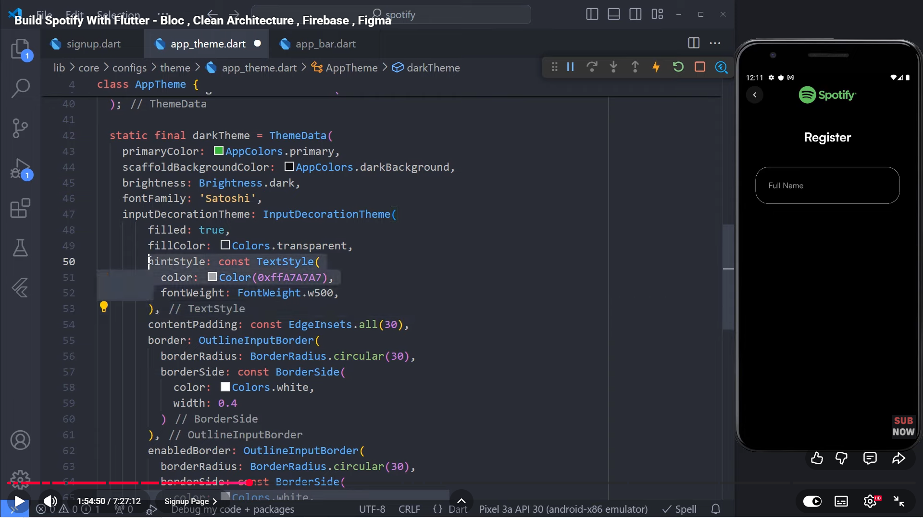

1. Register will be like this:

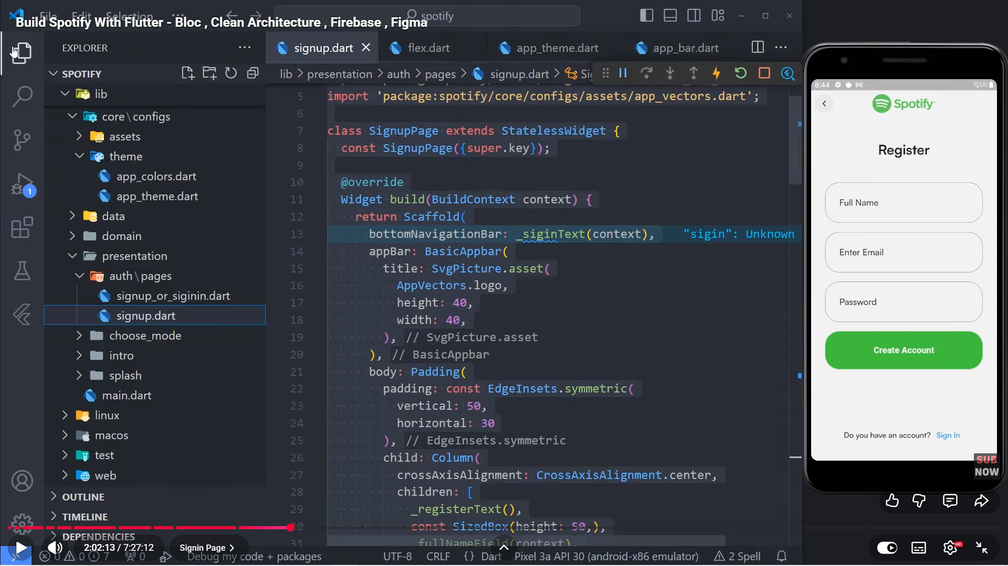

**Note:**  
Make sure your ThemeCubit is defined **once** and imported from the **same file everywhere**.  
Even if two cubits have identical code, Flutter treats them as different types if they come from different paths, which will cause ProviderNotFoundException.

**Note:** Always import ThemeCubit from a single source. Different import paths = different cubit types.

1. Configure firebase in the project
2. Create folder auth in domain/entities and create file user.dart

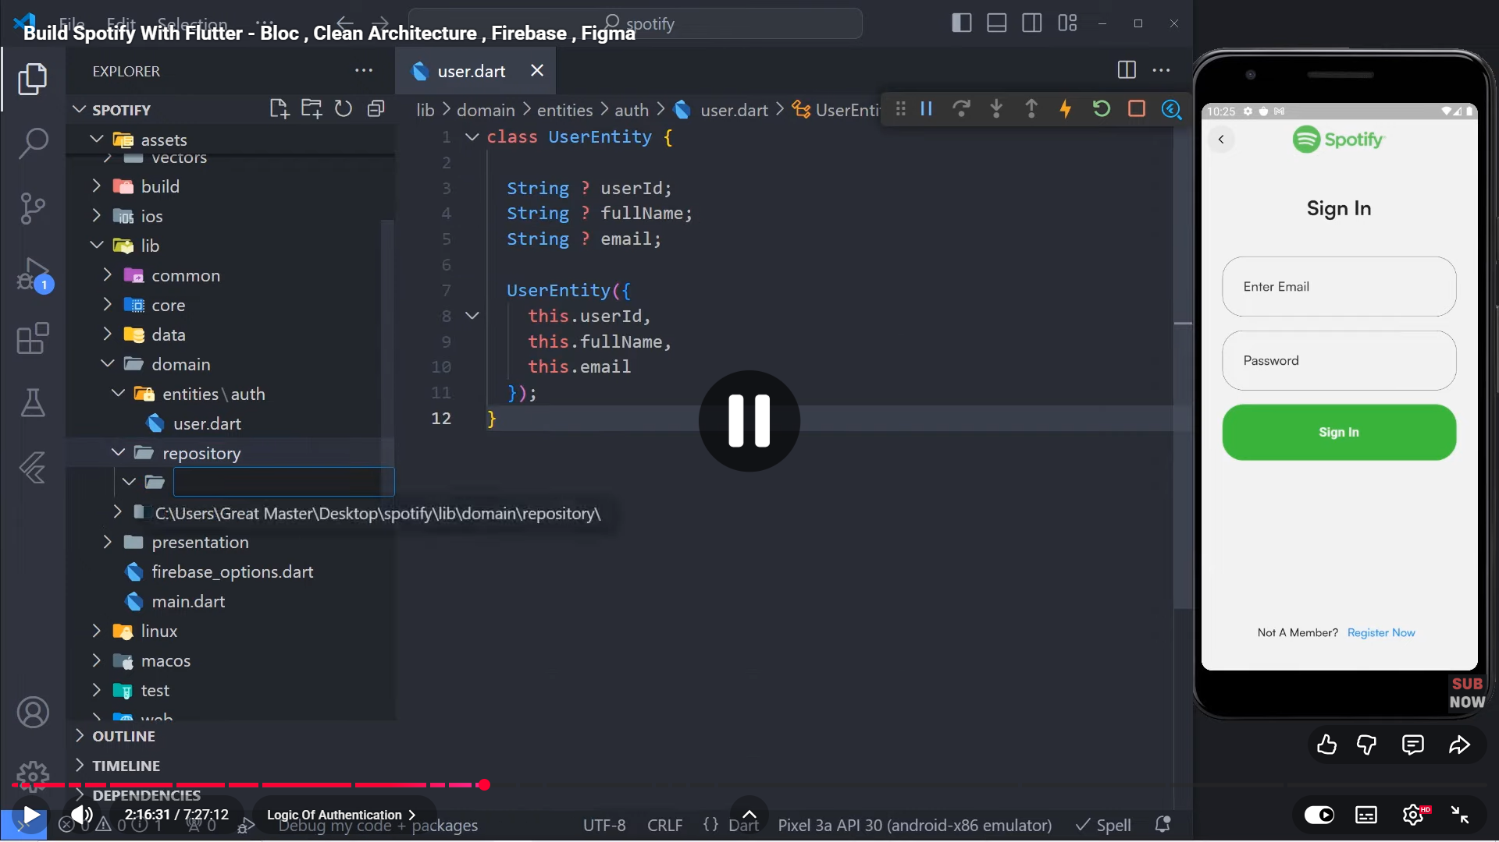

This file defines the core User entity used by the application.  
The entity is independent of Firebase and UI, ensuring business logic is not tied to any external service.  
This separation allows the backend implementation to change without affecting the app logic.

1. Create folder auth in domain/repository and create file auth.dart

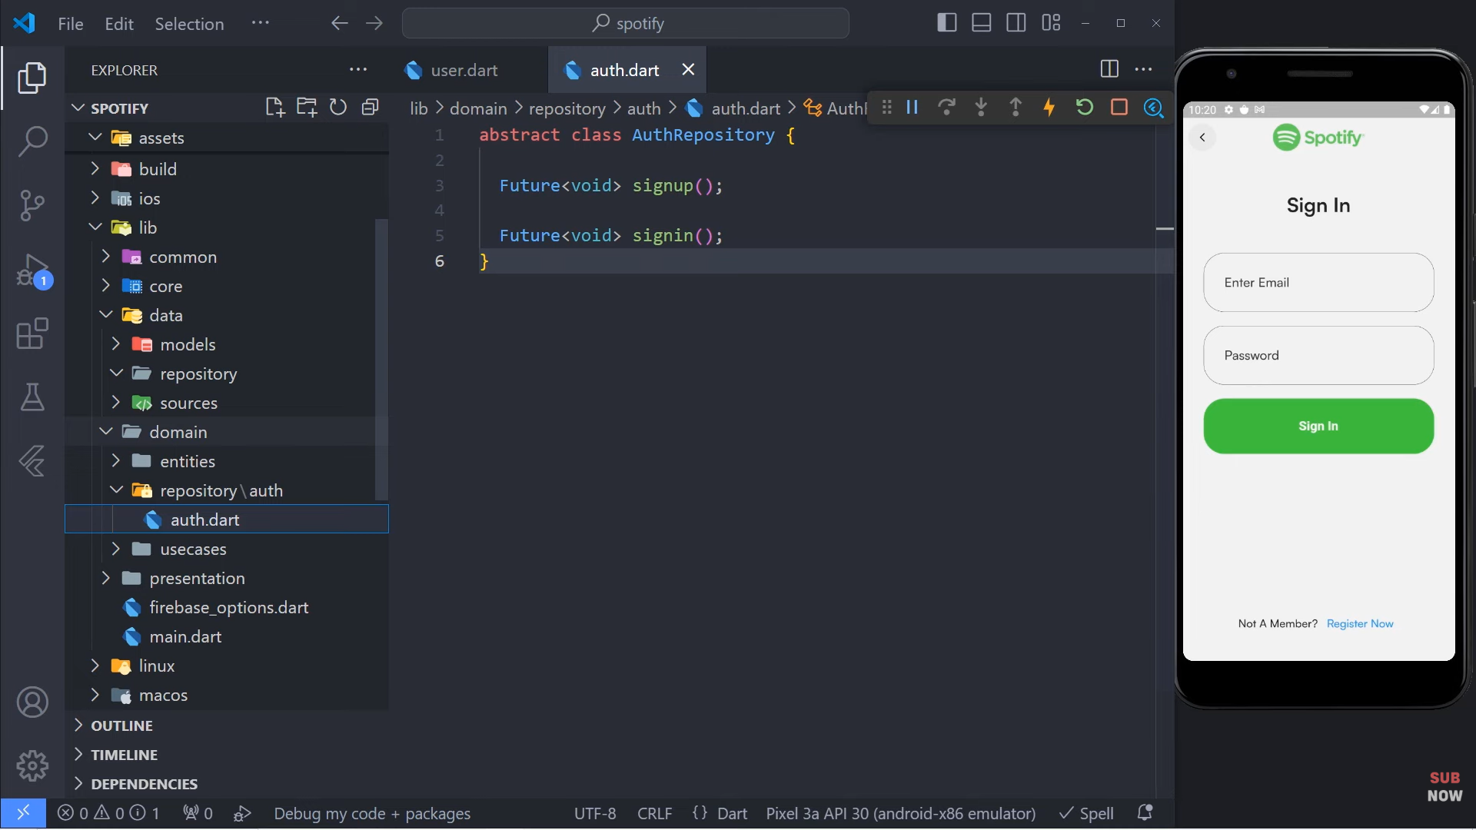

This repository defines a contract for authentication operations.  
It decouples the application logic from the actual authentication implementation.  
This abstraction enables flexibility and improves maintainability.

1. Create folder auth in data/sources and create file auth_firebase_service.dart

This service handles direct communication with Firebase Authentication.  
It isolates Firebase-specific logic from the rest of the application.  
This prevents Firebase APIs from leaking into business logic or UI layers.

1. Add firebase_auth in pubspec.yaml

This dependency provides access to Firebase Authentication APIs.  
It is required for implementing user sign-up and sign-in functionality.  
Without it, the app cannot interact with Firebase Auth services.

1. Create file create_user_req.dart in the models/auth

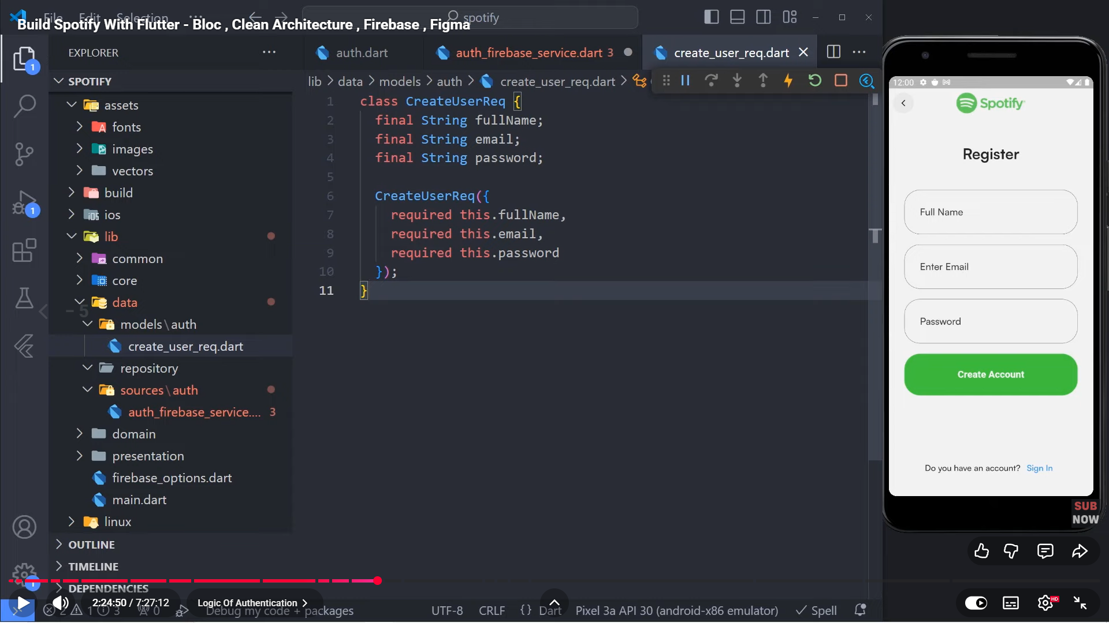

This model encapsulates user registration data in a structured object.  
It improves scalability by allowing new fields to be added without changing method signatures.  
This approach keeps the codebase clean and extensible.

1. Add extension get_it
2. Create file service_locator in lib

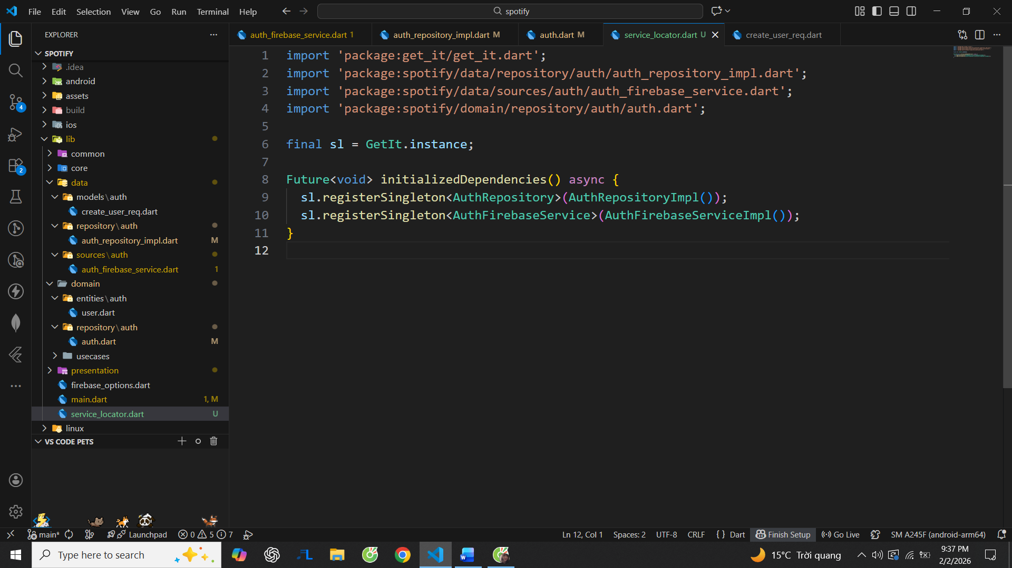

The service locator manages dependency injection across the application.  
It centralizes object creation and lifecycle management.  
This prevents tight coupling and simplifies testing and maintenance.

1. Create file auth_repository_impl in data/repository



This class implements the authentication repository contract.  
It connects the domain layer with Firebase services.  
This ensures the domain layer remains independent of external implementations.

1. Create usecase.dart in configs/usecase

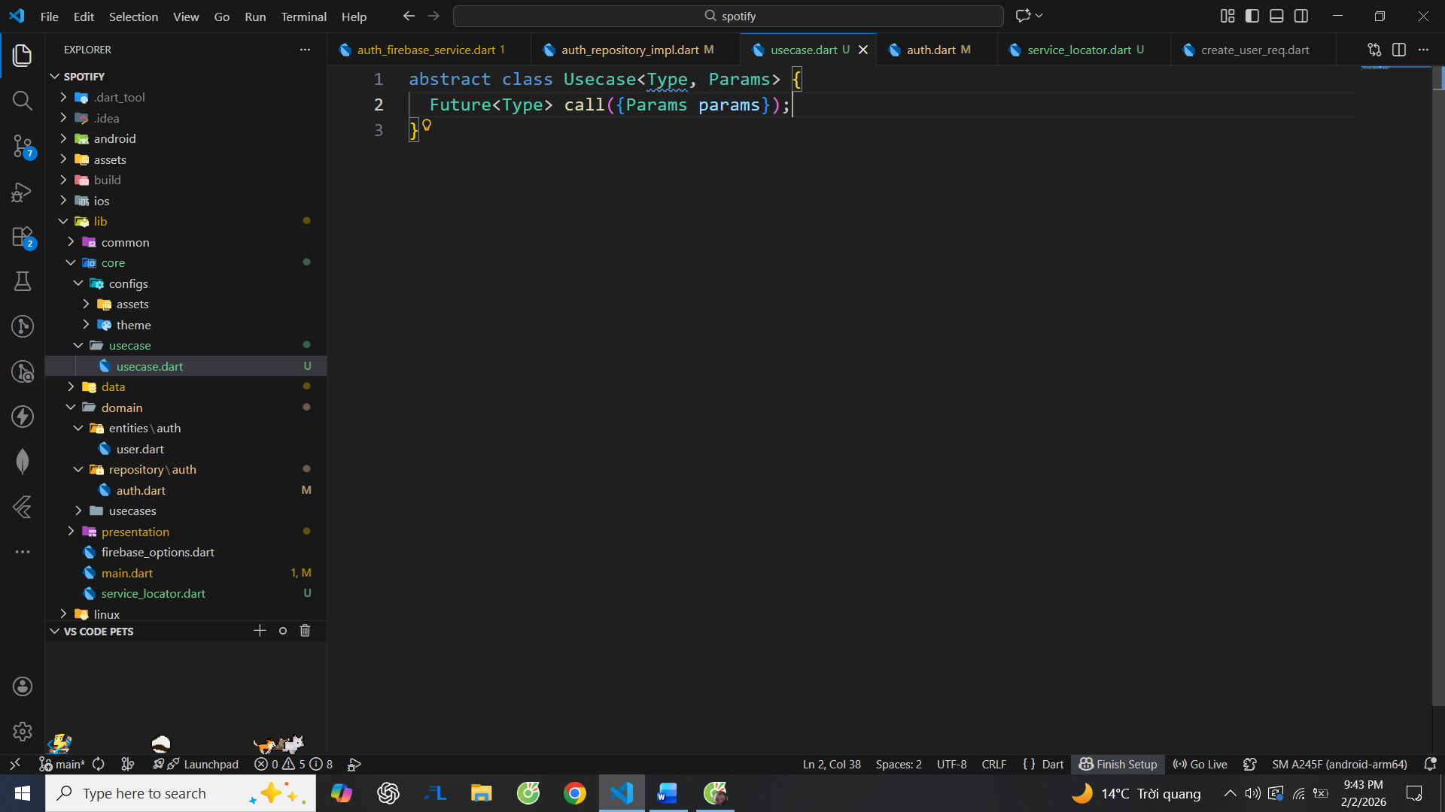

Use cases represent single, specific business actions.  
They enforce a clear separation between UI and business logic.  
This structure improves readability, testability, and scalability.

1. Add extension dartz

The dartz package provides functional error handling tools such as Either.  
It forces explicit handling of success and failure cases.  
This reduces hidden errors and improves code reliability.

1. Create signupUsecase in domain/usecases/auth

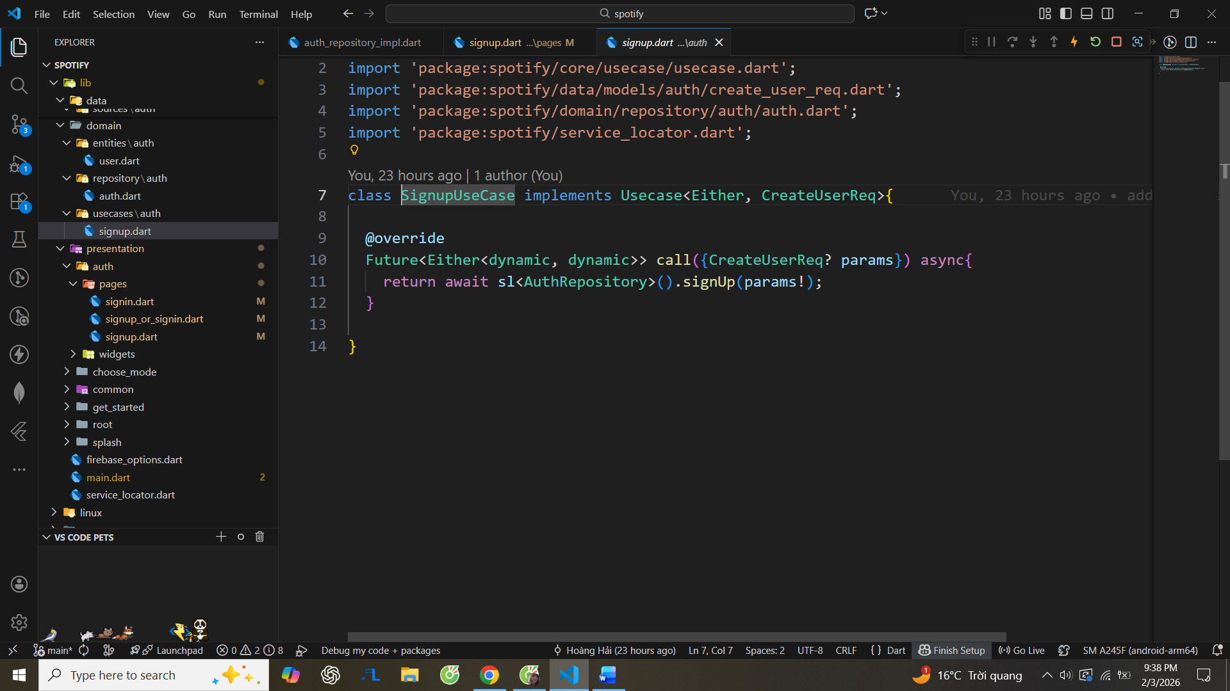

1. Auth_firebase_service will be like this:

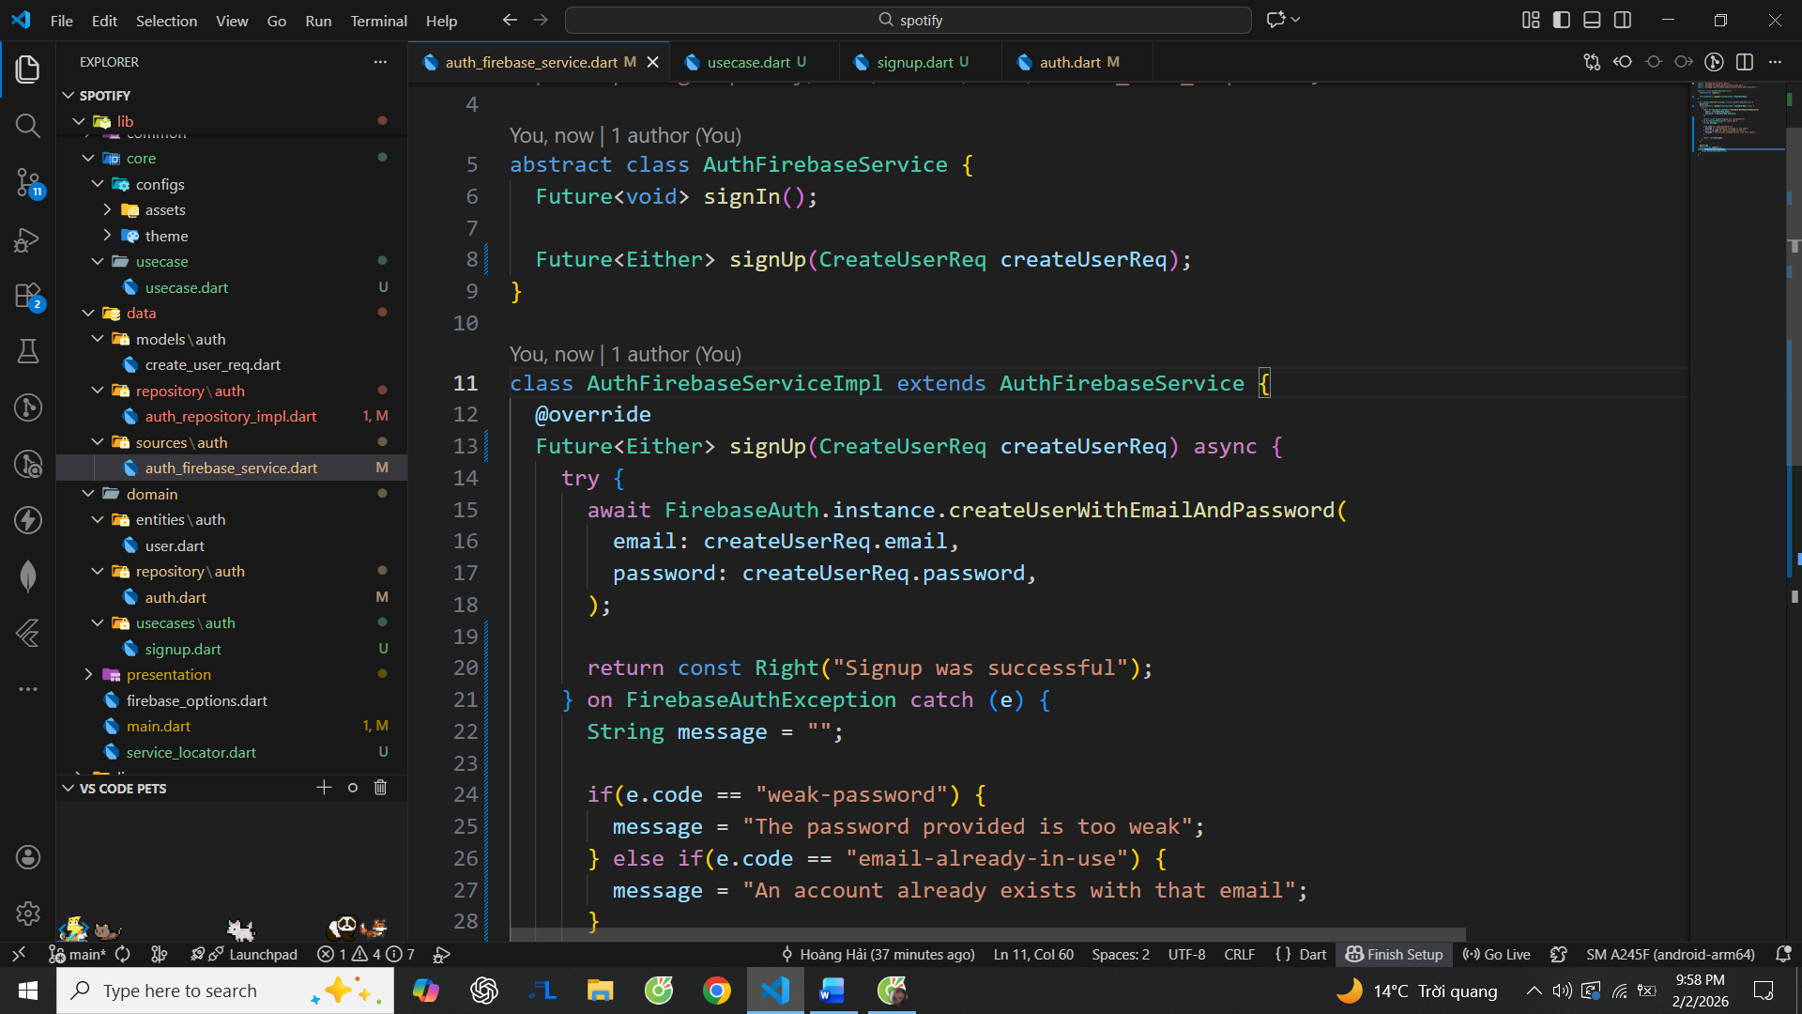

This implementation contains all Firebase authentication operations.  
It centralizes error handling and external API calls.  
This design keeps higher layers clean and focused on logic.

1. In signup in presentation add some codes:

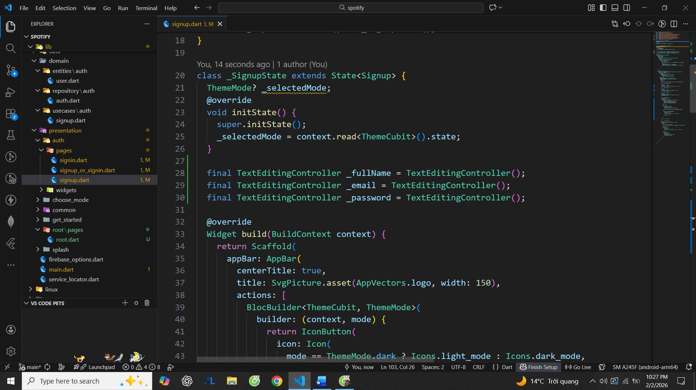

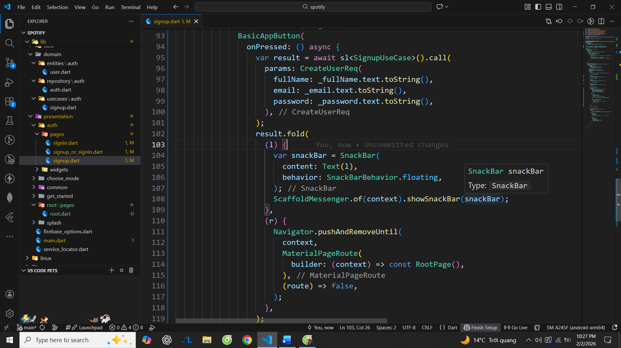

The presentation layer should only handle user interaction and state management.  
Business logic is delegated to use cases through Bloc or Cubit.  
This separation prevents UI code from becoming complex and fragile.

1. I’ve identified and fixed the issue where the app was stuck on the splash screen.

**Root cause:**  
The app was awaiting Firebase.initializeApp() inside main().  
On Android, Firebase initialization can block (especially on emulator or when Google Play Services/configuration is incomplete). Because runApp() was never reached, Flutter UI was not rendered, while the native splash screen kept showing—making it look like the app was frozen.

**Why there was no error:**  
Firebase does not fail fast in this case. It waits silently, so there was no red log or crash.

1. **Fix:**

Removed Firebase initialization from main()

Let the app render UI first

Initialized Firebase asynchronously inside the splash/initial screen instead

This prevents blocking app startup and makes the behavior deterministic.

1. Flow:

UI → Bloc → UseCase → Repository → FirebaseService → Firebase

Firebase → Repository → UseCase → Bloc → UI

1. Create signin_user_req in data/models/auth

